Portable Power Station
Model | 2500W/2000Wh
Model | 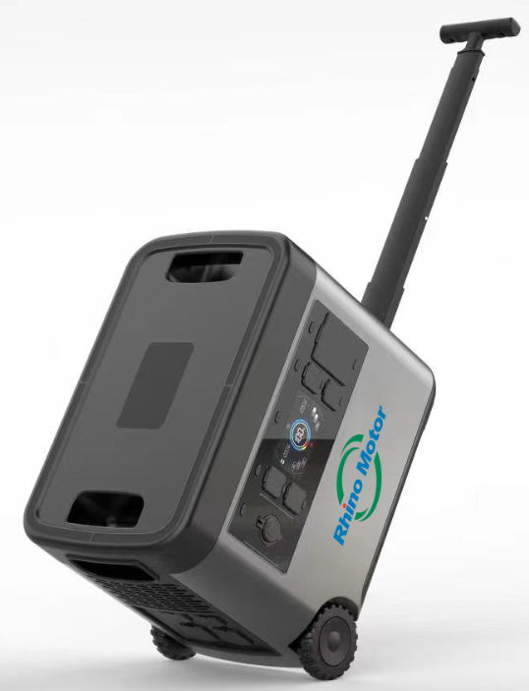
Capacity | 2000Wh LiFEPO4 Battery
AC output | 2500W continuous/Peak power 4000W
Weight | 28Kg
Dimension | 520*250*420mm
Input | AC Fast charging :1600W- 1.6h 100% ;1h 80% ;  Solar Panel: 750W / 12V-40V
AC / USB ports | AC 110V *4  USB-A：QC3.0 *3 /5V2.4A*3  USB-C：PD65*1 /5V2.4A *2:  Wireless charger *2
Car port output | 12V8A
LED Flashlight | 3W LED
Operation Temp. | -10 to 40
Recharging Temp | 0 to 40
Battery Life cycles | 2000
BMS | Under voltage Protection  Over voltage Protection  Over current in Charge/Discharge protection  Short Circuit protection  Over temperature protection  Overcharging voltage
Warranty | 12 months
MPPT (solar charging) | Suppot Mppt Solar charging
Portable Power Station
Model | 1200W/1050Wh
Model | 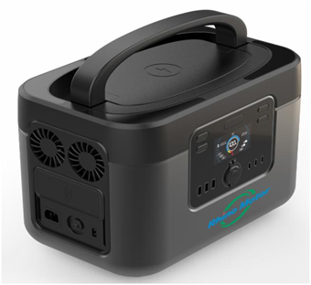
Capacity | 1050Wh LiFEPO4 Battery
AC output | 1200W continuous/ Peak power 2000W
Weight | 15Kg
Dimension | 366*235*267mm
Input | AC Fast charging :1000W- 1.5h 100% ;1h 80% ;  Solar Panel: 300W / 26V-40V
AC / USB ports | AC 110V *3  USB-A：QC3.0 *1 /5V2.4A*2  USB-C：PD65*1 /5V2.4A *2:  Wireless charger *1
Car port output | 12V8A
LED Flashlight | 3W LED
Operation Temp. | -10 to 40
Recharging Temp | 0 to 40
Battery Life cycles | 2000
BMS | Under voltage Protection  Over voltage Protection  Over current in Charge/Discharge protection  Short Circuit protection  Over temperature protection  Overcharging voltage
Warranty | 12 months
MPPT (solar charging) | Suppot Mppt Solar charging

